|  |  |
| --- | --- |
| Supervisor : | Mudassir Arif |
| Batch : | 2309d |
| Group : | BidSpirit |

|  |  |  |
| --- | --- | --- |
| Serial No | Enrollment No | Student Name |
| 1. | 1509566 | Shahzaib |
| 2. | 1511648 | Muhammad Huzaifa |
| 3. | 1520286 | Muhammad Zeeshan |
| 4. | 1500600 | Mohit Kumar |

**BidSpirit**

**Acknowledgement**

The first, we would like to express my special thanks of gratitude to my teacher Sir Mudassir Arif who helped a lot in finalizing this project within the limited time frame, valuable counseling and assistance for the accomplishment of this project.

Secondly, we would also like to thanks the e-project team at Aptech gdn Head Office, who gave as the opportunity to do this interesting and wonderful project BidSpirit

Thirdly, we also thank the e-project team for giving this task to us.Following are the benefits of this Project:

• Re-enforcement of skills happens in the experimental learning process.

• It gives us a lot of confidence to face an interview as we have worked on a project. We can explain virtually everything on the subject we have learnt.

**Sydney**

.Furniture House is your one-stop destination for high-quality furniture in Sydney. With a wide range of stylish and durable pieces, we have something to suit every taste and budget. Whether you're looking for modern, minimalist designs or classic, timeless pieces, you'll find it all at Furniture House. Our friendly and knowledgeable staff are always ready to assist you in finding the perfect furniture for your home. Visit our showroom in Sydney today and experience the Furniture House difference.

1. Vastu-friendly designs for a harmonious home.

2. Customization options available to fit your unique style.

3. Affordable prices without compromising on quality.

4. Quick and reliable delivery service across Sydney.

5. Hassle-free returns and exchange policy for customer satisfaction.

6. Regular promotions and discounts for amazing deals.

. Furniture House is the ultimate destination for all your furniture needs in Sydney. We offer a wide selection of furniture pieces, including sofas, beds, dining sets, and much more. Our furniture is crafted with the highest quality materials and exquisite designs, ensuring both style and durability. Whether you're furnishing a cozy apartment or a spacious home, Furniture House has the perfect pieces to suit your taste and lifestyle. Visit us today and transform your space into a beautiful and comfortable haven.

**Problems Definition**

.The problems with Furniture House may include delivery delays, quality issues, lack of customer service, and complications in the returns process. Some customers have complained about receiving damaged or defective furniture. Others have experienced delays in delivery, which disrupted their plans. There have been feedback regarding slow response times and delays in resolving issues from the customer service team. The returns process has also been perceived as complicated by some customers. These are some common problems that one may encounter with Furniture House.

.There have been instances where customers didn't receive proper updates about their orders, causing confusion and frustration. Additionally, some people have mentioned that the website can be a bit glitchy, making it difficult to navigate and place orders smoothly. These are important factors to consider when choosing to shop at Furniture House.

**Customer Requirement Specification (CRS)**

.The Customer Requirement Specification (CRS) is a document that outlines the specific needs and expectations of the customer regarding a product or service. It serves as a guide for the development team to understand and fulfill the customer's requirements. The CRS typically includes details such as the desired features, functionality, performance criteria, and any specific constraints or limitations. By clearly defining the customer's expectations, the CRS helps ensure that the final product meets their needs and leads to customer satisfaction.

There are so many popular furniture styles to choose from! Some common ones include:

1. Modern: Clean lines, minimalistic design, and a focus on functionality.

2. Contemporary: Similar to modern, but with a bit more flexibility and experimentation.

3. Mid-century modern: Inspired by designs from the mid-20th century, featuring organic shapes and sleek lines.

4. Scandinavian: Known for its simplicity, natural materials, and light color palettes.

5. Industrial: Incorporates elements like exposed brick, metal, and reclaimed wood for a rugged, urban look.

6. Traditional: Classic and timeless, often featuring ornate details, rich colors, and formal arrangements

.

7. Bohemian: Eclectic and free-spirited, with a mix of patterns, textures, and vibrant colors.

8. Modern: It's all about sleek lines, simplicity, and functionality. Think clean shapes, neutral colors, and a clutter-free look.

9. Contemporary: This style is similar to modern but allows for more flexibility and experimentation. You'll find a mix of different materials, textures, and bold accents.

10. Mid-century modern: Inspired by the designs of the mid-20th century, this style features organic shapes, tapered legs, and a blend of natural and vibrant colors.

11. Scandinavian: Known for its minimalist approach, Scandinavian furniture emphasizes functionality and natural materials like light-colored woods. It creates a cozy and airy atmosphere.

12. Industrial: This style takes cues from old factories and warehouses, with elements like exposed brick, metal accents, and distressed finishes. It's all about a rugged and urban look.

13. Traditional: Classic and timeless, traditional furniture often features ornate details, rich colors, and elegant fabrics. It creates a formal and sophisticated ambiance.

14. Bohemian: If you're into a free-spirited and eclectic vibe, bohemian style is for you. It's all about mixing patterns, textures, and vibrant colors to create a relaxed and artistic space.

**Scope Of Work (Briefly)**

.They design and make furniture, both from scratch and by customizing existing designs to fit what customers want. They also help customers out by giving advice, answering questions, and making sure they're happy with their furniture choices.

.Managing inventory is a big part of the job too, making sure they have enough stock and getting more when they need it. And of course, they deliver the furniture to customers' homes and offices, and even help set it up if needed. If something goes wrong with the furniture, they can fix it up too.

. Plus, they might even offer interior design services to help customers create the perfect look for their spaces. And let's not forget about marketing and promotions, spreading the word about their awesome furniture through ads and social media. It's a busy and exciting place to work

**Aggregated Sitemap**

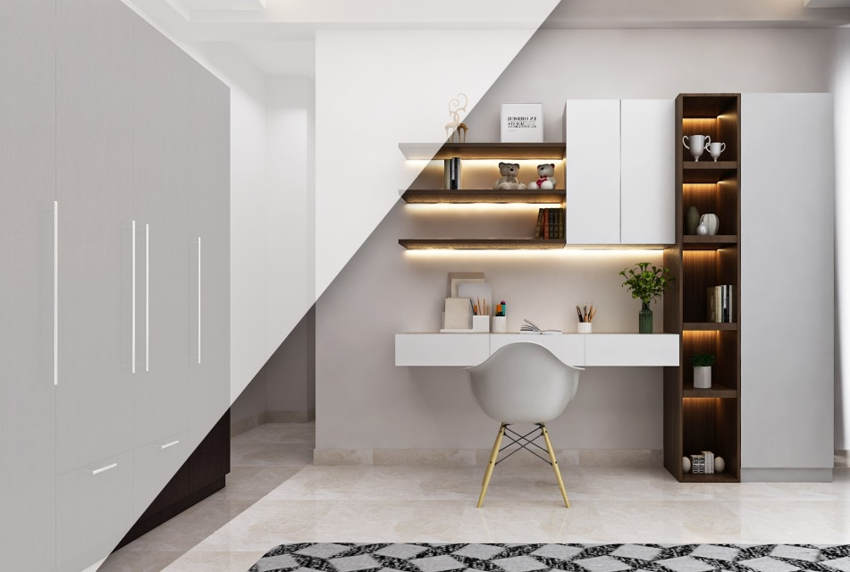

Home Page

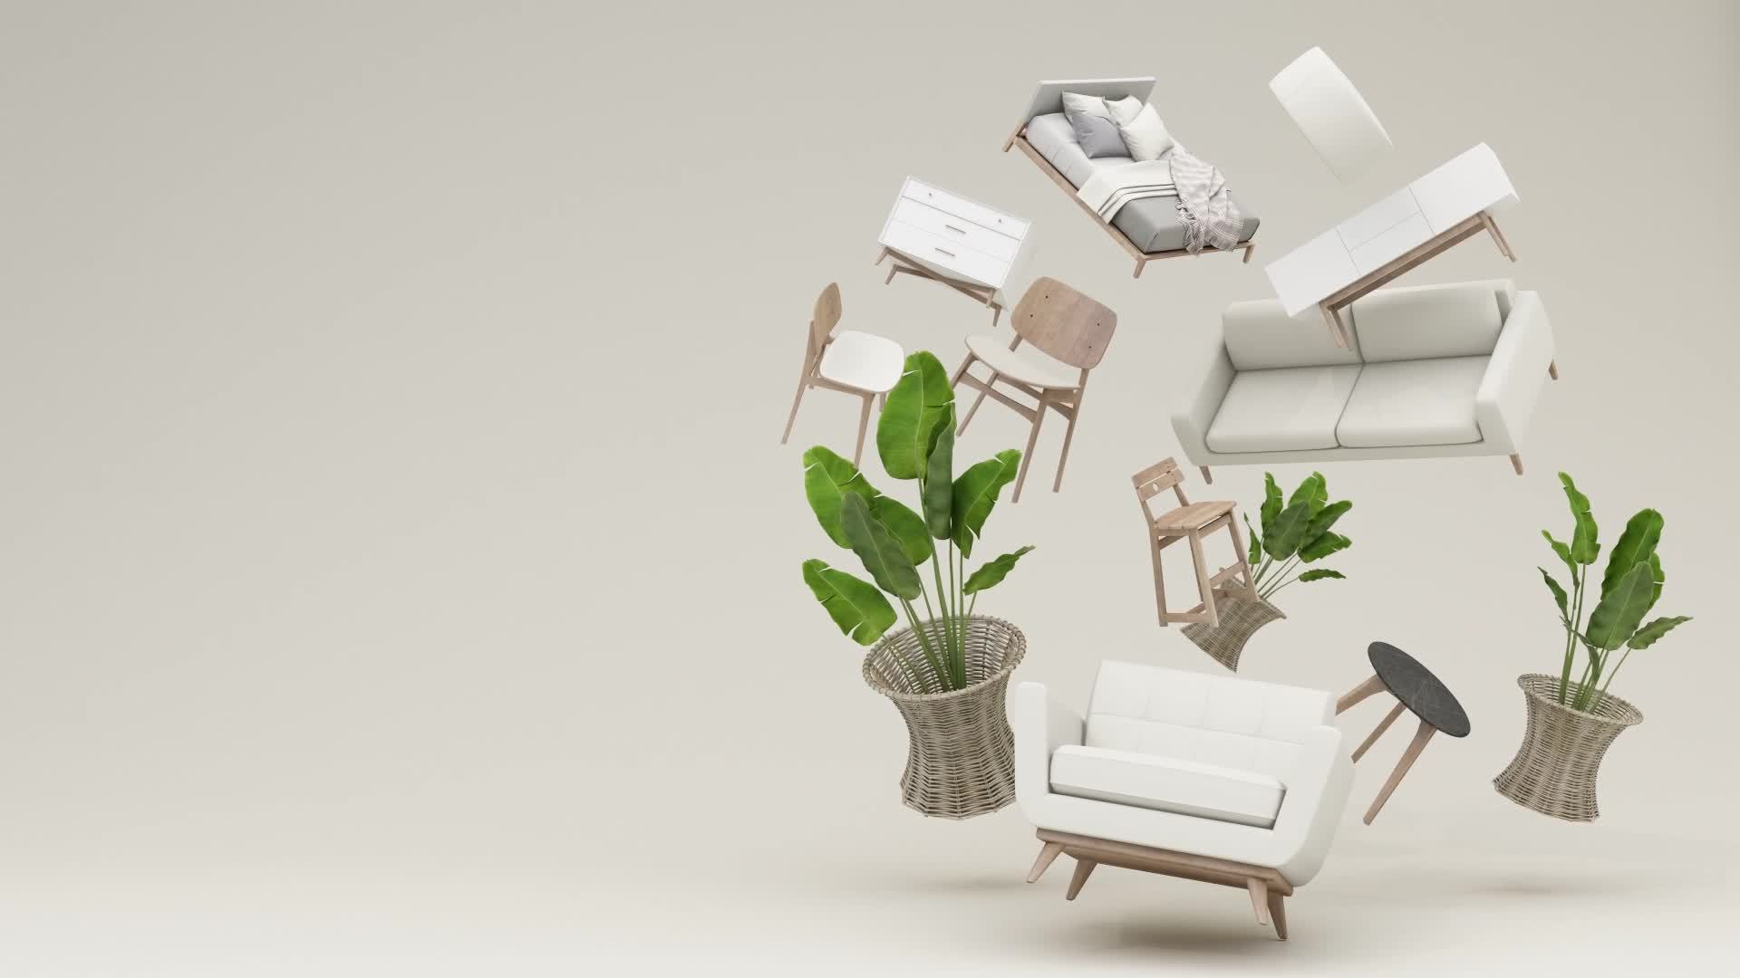

Home Page

**Sitemap English**

**NEW ARRIVAL PAGE**

**HOME PAGE**

**A**

**CONTACT PAGE**

**FOOTER**

**CARDS**

**OUR PARTNERS PAGE**

**ABOUT PAGE**

**Wireframes**

**Layout**

|  |
| --- |
| **Furniture House** Home New Arrival About Contact Our Partners Login/SignUp |
| **Heading**  **paragraph**  Shop Now    **Background image** |
|  |

**Bottom Layout**

|  |  |  |  |  |  |  |  |  |  |  |  |
| --- | --- | --- | --- | --- | --- | --- | --- | --- | --- | --- | --- |
| **Home Page**   |  | | --- | | **Image** |  |  | | --- | | **image** |  |  | | --- | | **image** |   **Furniture Name**   |  | | --- | | **image** |   **Furniture Name**   |  | | --- | | **image** |  |  | | --- | | **Image** |  |  | | --- | | **image** |   **Contact page**  Name   |  | | --- | |  |   Email address   |  | | --- | |  |   Message   |  | | --- | |  |   Submit    **About Page**   |  | | --- | | **image** |   **Paragraph**  Learn more |

|  |  |  |  |  |  |
| --- | --- | --- | --- | --- | --- |
| **Model Page**   |  |  | | --- | --- | | |  | | --- | | **.**  **image** |   Add to Card  **Furniture Name**  **Paragraph**  **\*\*\*\*\*\*\*** |   **Login page**   |  |  |  | | --- | --- | --- | | **Login**   |  | | --- | | Email address |   Login   |  | | --- | | Password | | |

|  |  |  |  |  |  |  |
| --- | --- | --- | --- | --- | --- | --- |
| **signUp Page**   |  |  |  |  |  |  | | --- | --- | --- | --- | --- | --- | | **SignUp**   |  | | --- | | **Username** |  |  | | --- | | **Name** |  |  | | --- | | **Date Of Birth** |  |  | | --- | | **Email address** |   SignUp   |  | | --- | | **Password** | | |

**Task Sheet**

|  |  |  |  |  |  |  |  |
| --- | --- | --- | --- | --- | --- | --- | --- |
| **Project Ref.No:**  **Ep/Advertisement**  **Portal management System / 01** | | **Project Title** | **Date Of Preparation Of Activity Plan** | | | | |
| **No** | **Task** |  | **Actual start Date** | **Actual Date** | **Team- Mate Names** | | **Status** | |
| **1.** | **Home Page** | **24**  **-**  **Nov**  **-**  **2024** | **16**  **-**  **Days** | Shahzaib |  |  | |
| **2.** | **About**  **page** | Muhammad  huzaifa |  |
| **3.** | **Contact page** |
| **4.** | **Model page** | Mohit kumar |  |
| **5.** | **Login/Signup page** | Muhammad  Zeeshan |  |